**Launch Endpoint Installation & Configuration**

**This article has been updated to support v12.0.1 of the Goliath Application Availability Monitor.**

This article will review the process of creating a new launch endpoint for Citrix Virtual Apps and Desktops, VMware Horizon, Microsoft RDS and Cerner Patient Portal. The Launch Endpoint is the server, virtual machine, or workstation in which the Application Availability Monitor (GAAM) will be executing the platform launches from.

**Article Contents:**

* [Prerequisites](https://support.goliathtechnologies.com/hc/en-us/articles/360024769993-Launch-Endpoint-Installation-Configuration#h_01G63REFWG06NVKE90CYHMQYYX)
* [Installation](https://support.goliathtechnologies.com/hc/en-us/articles/360024769993-Launch-Endpoint-Installation-Configuration#h_01G63REQE5PPDDQ04RK39YX8P2)
  + [Automated via Installer](https://support.goliathtechnologies.com/hc/en-us/articles/360024769993-Launch-Endpoint-Installation-Configuration#h_01G63RTCAPVCE7T0X222HC34Q9)
  + [Manual Installation](https://support.goliathtechnologies.com/hc/en-us/articles/360024769993-Launch-Endpoint-Installation-Configuration#h_01G63REZ6GGARJRKSD24KT5JA5)
* [Launch Preparation](https://support.goliathtechnologies.com/hc/en-us/articles/360024769993-Launch-Endpoint-Installation-Configuration#h_01G63RWKSM8YXE6EZTN3049CWZ)
* [Post Configuration, What's Next?](https://support.goliathtechnologies.com/hc/en-us/articles/360024769993-Launch-Endpoint-Installation-Configuration#h_01G63RF8A5V83B9E5KP71XW83C)

**Prerequisites**

Before continuing, please review the [Goliath Application Availability Monitor Prerequisites](https://support.goliathtechnologies.com/hc/en-us/articles/360024993934)

**Installation**

The GAAM Launch Endpoint can be installed two ways 1) Automated via an Installer or 2) Manually. Please see the relevant sections below for installation steps.

**Automated via Installer**

1. On the Goliath Server, navigate to the ‘Bin’ folder within the install directory.
   1. Depending on your Goliath version, the default location is one of hte following:
      1. ‘C:\Program Files (x86)\MonitorIT\Bin’
      2. ‘C:\Program Files\MonitorIT\Bin’
2. Locate the **‘GAAMEndpoint’**executable
   1. If the launches will be executing locally on the Goliath Server, launch this executable as the user Windows Service Account created for GAAM
   2. If the launches will be executing on a remote machine:
      1. Log into the remote machine as the Local Windows Service Account created for GAAM
      2. Copy over the **‘GAAMEndpoint’**executable and launch it
         1. Note, this file can also be downloaded via <https://____/bin/gaamendpoint.exe>where the blank if the address of the Goliath web console
3. The executable will start the install process and display a Welcome screen, click **‘Next’** to proceed.
   1. 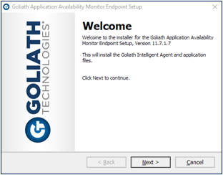
4. The installer will prompt for the launch type, Citrix XenApp & XenDesktop is selected by default, choose the option for the virtualization environment that will be tested and then click **‘Next’**to proceed. For Cerner Patient Portal please choose the option for ‘Other’.
   1. 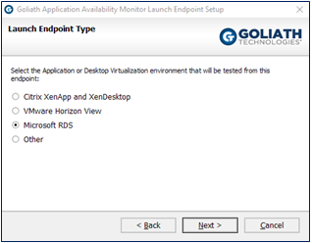
5. If the launch endpoint is the Goliath Server, proceed to step6. If the launch endpoint is a remote machine, enter the ‘**IP Address’**or **‘DNS Name’**for the Goliath Server and the port used for agent communication (default is 443)
   1. 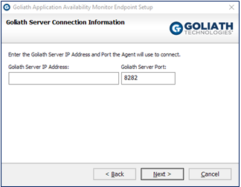
6. If the launch endpoint is the Goliath Server, proceed to step 6. If the launch endpoint is a remote machine, you will next be prompted to verify the install directory of the technology.
   1. 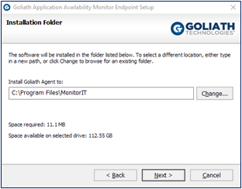
7. Next, choose if you'd like to disable UAC at the system level via the installer. **Please note, a reboot is required in order for the change to take place. Also, if UAC is not disabled the technology will not function and the configuration will be incomplete.**
   1. 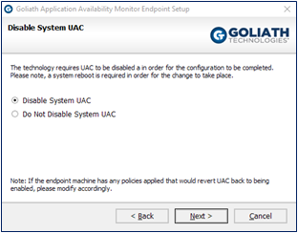
8. Verify that the following installation settings are correct, if so select **‘Next’**to proceed with the installation or **‘Back’** to make the appropriate modifications.
   1. 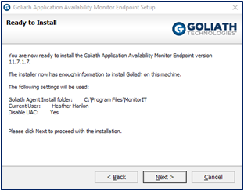
9. During the installation process, a progress bar will show the progress of installing the Launch Endpoint, as seen in the figure below.
   1. 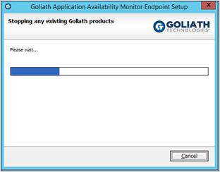
10. Once the Launch Endpoint is successfully installed the install program will display a message that the installation is complete. Click ‘Finish’ to exit the install program.
    1. 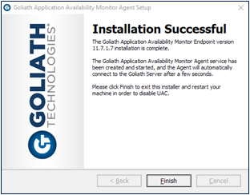
    2. If the Launch Endpoint is not fully installed the install program will display a message that the installation requires further configuration.
       1. 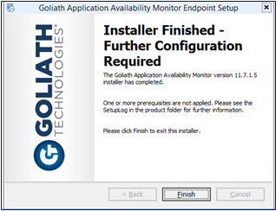
       2. This message can if any/all of the below are missing:
          1. End User Opted out of Disabling UAC
          2. Citrix – Citrix Receiver or Workspace App is not installed
          3. VMware – VMware Horizon View Client is not installed
          4. This information can be found in the SetupLog located in the install directory.
11. For Citrix & VMware, make sure the appropriate client is installed.
12. Optionally, Goliath recommends configuring Automatic Logons for the Windows Service Account so that if the endpoint machine is ever shut down or restarted, the service account will be logged back in automatically and the launches will be resumed. This can be done by:
    1. Navigating to the install directory:
    2. Default location is ‘C:\Program Files\MonitorIT’
    3. Opening the folder labeled ‘AutoLogon’
    4. Launching the ‘AutoLogon’ executable and following the on-screen prompts

Now that the endpoint has been configured, please see the next section for [Launch Preparation](https://support.goliathtechnologies.com/hc/en-us/articles/360024769993-Launch-Endpoint-Installation-Configuration#h_01G63RWKSM8YXE6EZTN3049CWZ).

**Manual Installation**

1. **Windows Account that is always in a Logged on (active) or Disconnected state:**
   1. Since GAAM is creating real Citrix/VMware/RDS/Patient Portal sessions, you will need a local or domain service account that is connected the endpoint at all times, either logged in or disconnected. Please create this service account and **log in with it to the GAAM Endpoint machine before continuing.**
   2. We suggest enabling Automatic logons for this account so that if the machine is rebooted the user will be logged in right away. Here is a link to a Windows Utility that will allow you to accomplish this <https://technet.microsoft.com/en-us/sysinternals/autologon.aspx>
2. **UAC Disabled at the Kernel/System level**:
   1. While the GAAM schedules are executing, the technology is making a number of system level call. In order to avoid unexpected prompt, UAC must be disabled at the system level (not through Control Panel). To accomplish this, Goliath includes a registry file to update the system. This file **requires a machine reboot**. Below are instructions:
      1. On the Goliath Server, open Windows File Explorer and navigate to **C:\Program Files (x86)\MonitorIT\Tools or C:\Program Files\MonitorIT\Tools** depending on your product version
      2. Locate the **Disable_UAC**.**reg**file and copy it over to the launch endpoint(s)
      3. Double click to run the file
      4. A warning will appear for changing the registry, click **‘Yes’**to continue
         1. 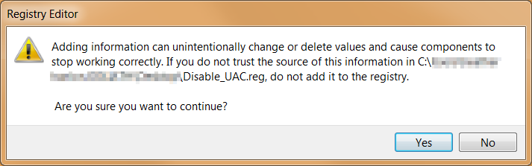
      5. A confirmation window will appear, click **Ok**
         1. 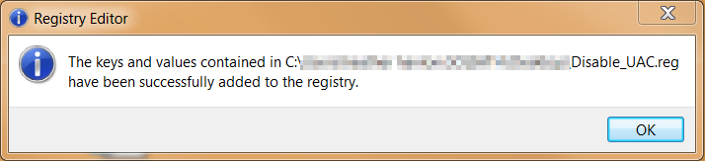
      6. Reboot the launch endpoint
3. **Goliath Agent:**
   1. The Goliath Agent is used to connect to the main Goliath server in order to run the launches at their scheduled time, as well as report the data back to the console. If your launch endpoint is the same as the goliath server there is no need to install the agent as it is deployed by default. Otherwise, please follow the steps in one of the article below for installing the agent.
      1. [Agent Installation/Update via Installer](https://support.goliathtechnologies.com/hc/en-us/articles/360025959993)
      2. [Agent Installation/Update via the Goliath Console](https://support.goliathtechnologies.com/hc/en-us/articles/360025093394)
      3. [Agent Installation/Update via Command Line](https://support.goliathtechnologies.com/hc/en-us/articles/360025008894)
      4. [Silent Agent Installation/Update](https://support.goliathtechnologies.com/hc/en-us/articles/360025012374)
4. **Client Specific Configuration:**
   1. VMware Horizon View Client(VMware Horizon Only):
      1. Since GAAM is creating real VMware Horizon sessions, the VMware Horizon View Client is required in order to execute the launches. Below are instructions on how to determine if the VMware Horizon View Client is installed.
      2. Open Windows Control Panel
      3. In the top right hand corner, change the ‘View By’ option to be ‘Small Icons’
      4. Select ‘Programs and Features’
      5. Sort by Name and confirm if the VMware Horizon Client is installed. If not, please install it before continuing.
   2. Citrix Receiver/Workspace (Citrix Virtual Apps and Desktops Only):
      1. Since GAAM is creating real Citrix sessions, Citrix Receiver/Workspace is required in order to execute and run the ICA files. Below are instructions on how to determine if Citrix Receiver is installed.
      2. Open Windows Control Panel
      3. In the top right hand corner, change the ‘View By’ option to be ‘Small Icons’
      4. Select ‘Programs and Features’
      5. Sort by Name and confirm whether or not Citrix Receiver/Workspace is installed. If it is not, you can download the latest version of Citrix Workspace at the link provided <https://www.citrix.com/downloads/workspace-app/>
5. **LogonSimulator.exe is running:**
   1. The LogonSimulator.exe is the application that works with the Goliath Agent in order to execute the launches at their scheduled time. This application functions as a background process that must be running in order for the launches to execute. Please follow the below instructions for obtaining and executing the application.
      1. On the launch endpoint, open the **Start Menu** and run **shell:startup**
      2. On the Goliath Server, navigate to the Bin folder inside the install directory
         1. The default location is either **C:\Program Files (x86)\MonitorIT\Bin** or **C:\Program Files\MonitorIT\Bin**
      3. Copy the **LogonSimulator.exe** file and paste it into the **Startup folder** on the launch endpoint
      4. Double click to run the file, this file runs in the background so you will not see anything happen. Use Task Manager to confirm there is only 1 instance running
         1. If there are security prompts when you run it the first time, please uncheck the box to check the executable in the future, to ensure successful starts of LogonSimualtor.exe following restarts of the launch endpoint.

Now that the endpoint has been configured, please see the next section for [Launch Preparation](https://support.goliathtechnologies.com/hc/en-us/articles/360024769993-Launch-Endpoint-Installation-Configuration#h_01G63RWKSM8YXE6EZTN3049CWZ).

**Launch Preparation**

This section is only applicable for Citrix Virtual Apps and Desktop or Microsoft RDS launches. If using VMware Horizon please proceed to the next section, [Post Configuration, What's Next?](https://support.goliathtechnologies.com/hc/en-us/articles/360024769993-Launch-Endpoint-Installation-Configuration#h_01G63RF8A5V83B9E5KP71XW83C)

Citrix Virtual Apps and Desktop or Microsoft RDS launches are executing via Google Chrome under the profile of the windows account that is running the LogonSimulator.exe process. To ensure that the GAAM launches are successful, you'll want to first manually bypass any unexpected Chrome prompts.

For example, with Citrix deployments you'll want to repeat the following steps for each URL being tested:

1. Launch Google Chrome and navigate to the Storefront or NetScaler Gateway URL. Note if you see any of the following items as they'll be needed in the next section.
   1. Note if there is a "Detect Receiver" button that must be clicked before you are able to authenticate
   2. Note if there is a company issued EULA prompt hat must be clicked before you are able to authenticate
   3. If there is a "Open Citrix Receiver Launcher?" or "Open Citrix Workspace Launcher?" be sure to check the box for "Always Allow ....." before accepting
      1. 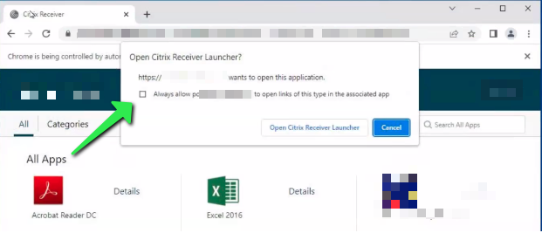
2. Authenticate to the Citrix Environment. Note if you see any of the following items as they'll be needed in the next section.
   1. Note if there is a "Detect Receiver" button that must be clicked before you are able to reach the storefront page
   2. Note if there is a company issued EULA prompt hat must be clicked before you are able to reach the storefront page
3. Click on an application or desktop to launch it. If the .ica files appears in the downloads bar at the bottom of the screen, click on the arrow and be sure to select "Always open files of this type"
   1. 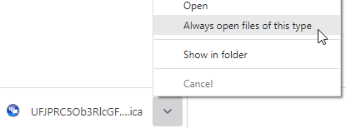

Once all of your URL(s) have been configured for the prompts to be bypassed, please proceed to the next section.

**Post Configuration, What's Next?**

Now that your GAAM endpoint(s) have been installed and configured. Please see the following articles for next steps to complete the setup.

1. [Configure the Launch Schedules](https://support.goliathtechnologies.com/hc/en-us/articles/360025158873)
2. Review [Launch Endpoint Maintenance](https://support.goliathtechnologies.com/hc/en-us/articles/360046852254) (recommended)
3. [GAAM Reporting](https://support.goliathtechnologies.com/hc/en-us/articles/360024498514)